**Task 12**

1. Command to find all the empty and non empty files/dir’s/links in a pwd/specific-path?

Synatx: find . –print

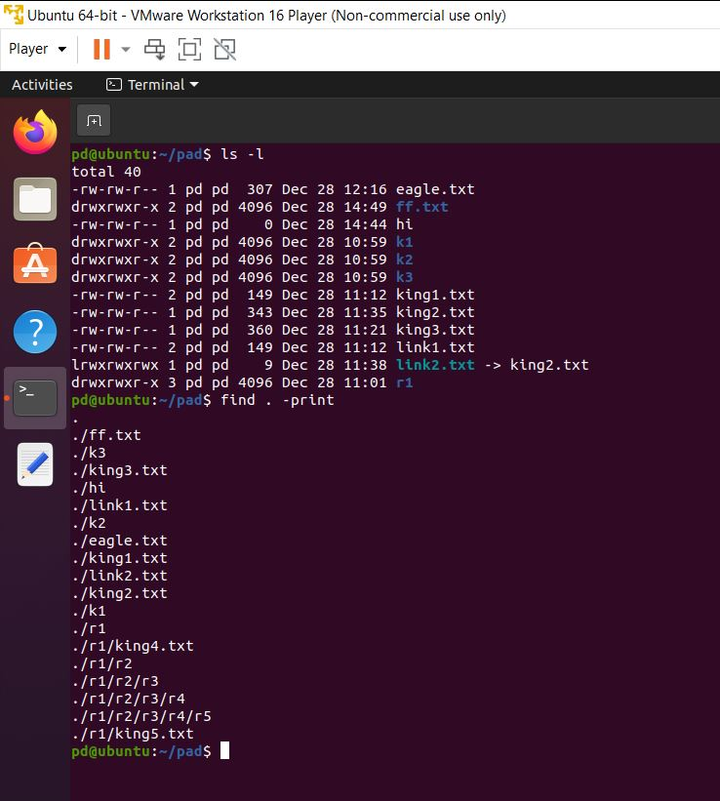

1. Find the files/dir’s based on some size and delete it?

Syntax: **find . –type f –size 82c –exec rm –f {} \;**

**-exec = This part of the find command is used to specify that command should be executed of a file/dir.**

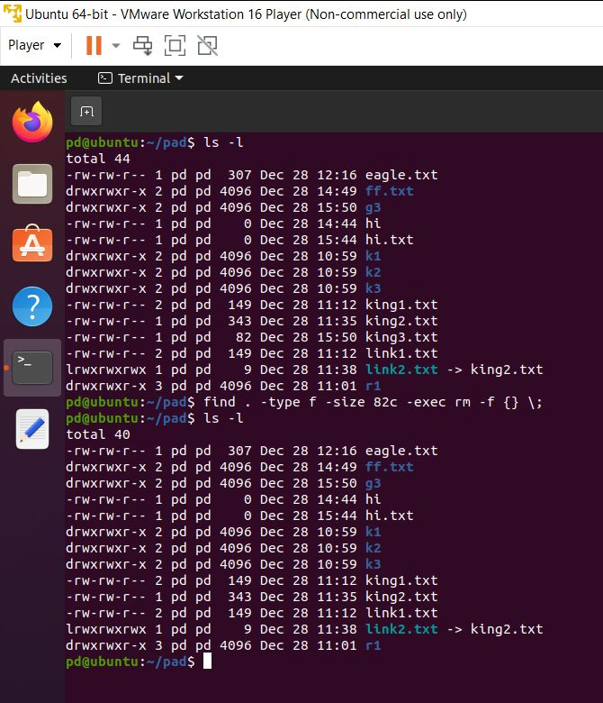

1. Find all the files with .txt and change the permission to 777

Syntax: **find . –type f –name ‘*.txt’ –exec chmod 777 {} \;**

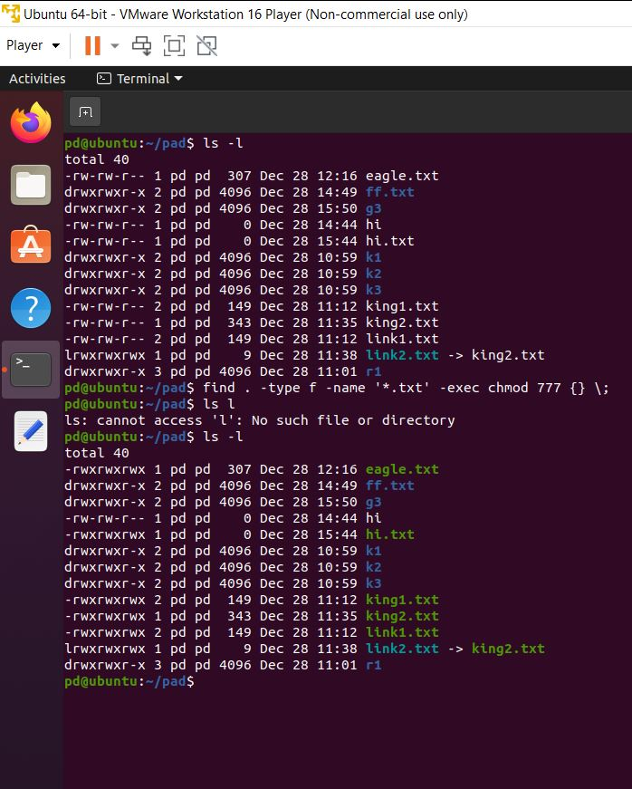

1. Command to display all the dir's with max depth2 (immediate 2 subdirectories)

hint: find . -maxdepth 2 -type d

Note:If there are n number of subdir's then above command will display only till 2 dir's

Syntax: **find . –type d –maxdepth 2**

